Serverless Development 101

**Module 05A – The Web Application using Serverless Computing and Dynamo DB**

1/10/2019 Developed by Kevin Wang

1/10/2019 Checked by Clark Jason Ngo

1/10/2019 Tested by Tuan Khai and Minh Truong

2/11/2019 Revised by Sam Chung

4/20/2020 Updated by Apiwat Chuaphan

Center for Information Assurance (CIAE) @City University of Seattle (CityU)

  

**Learning Outcomes**

* Learn how to add a DynamoDB table through Serverless framework.
* Learn how to configure the permission to operate the table.
* Learn how to add some data to the table for testing.
* Learn how to deploy a fetching API with Lambda.

[**Amazon DynamoDB**](https://aws.amazon.com/dynamodb/)

DynamoDB is a fully managed proprietary NoSQL database service that supports key-value and document database that delivers single-digit millisecond performance at any scale. It's a fully managed, multiregion, multimaster, durable database with built-in security, backup and restore, and in-memory caching for internet-scale applications. DynamoDB can handle more than 10 trillion requests per day and can support peaks of more than 20 million requests per second.

**Serverless Web Apps**

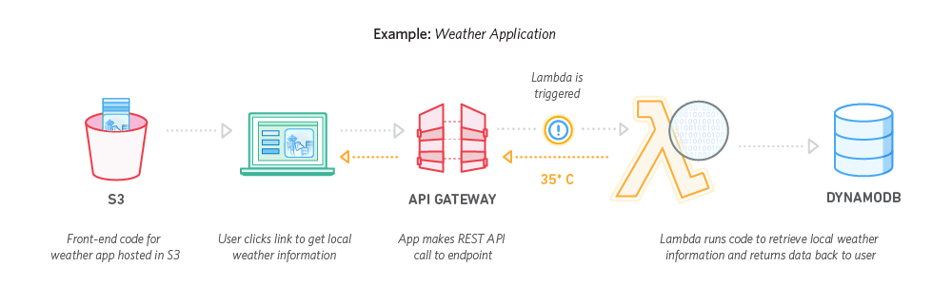

**Configuration – Function, Database, and IAM**

1. Open the VSCode and open the “**myproject**” project folder that we developed a web application using serverless computing in the previous module.
2. Open the “**serverless.yml**” file under the root folder and replace content with <https://bit.ly/2VnNY7o>   
   Note: There are couples of new things were added
3. A new function is defined

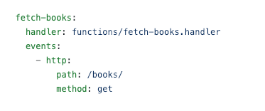

1. A DynamoDB table is defined

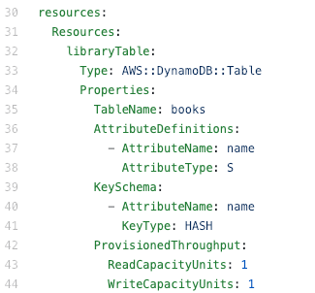

1. The scan operation permission is given to all function in this service

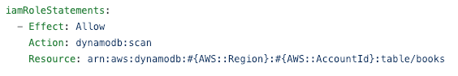

The updated “serverless.yml”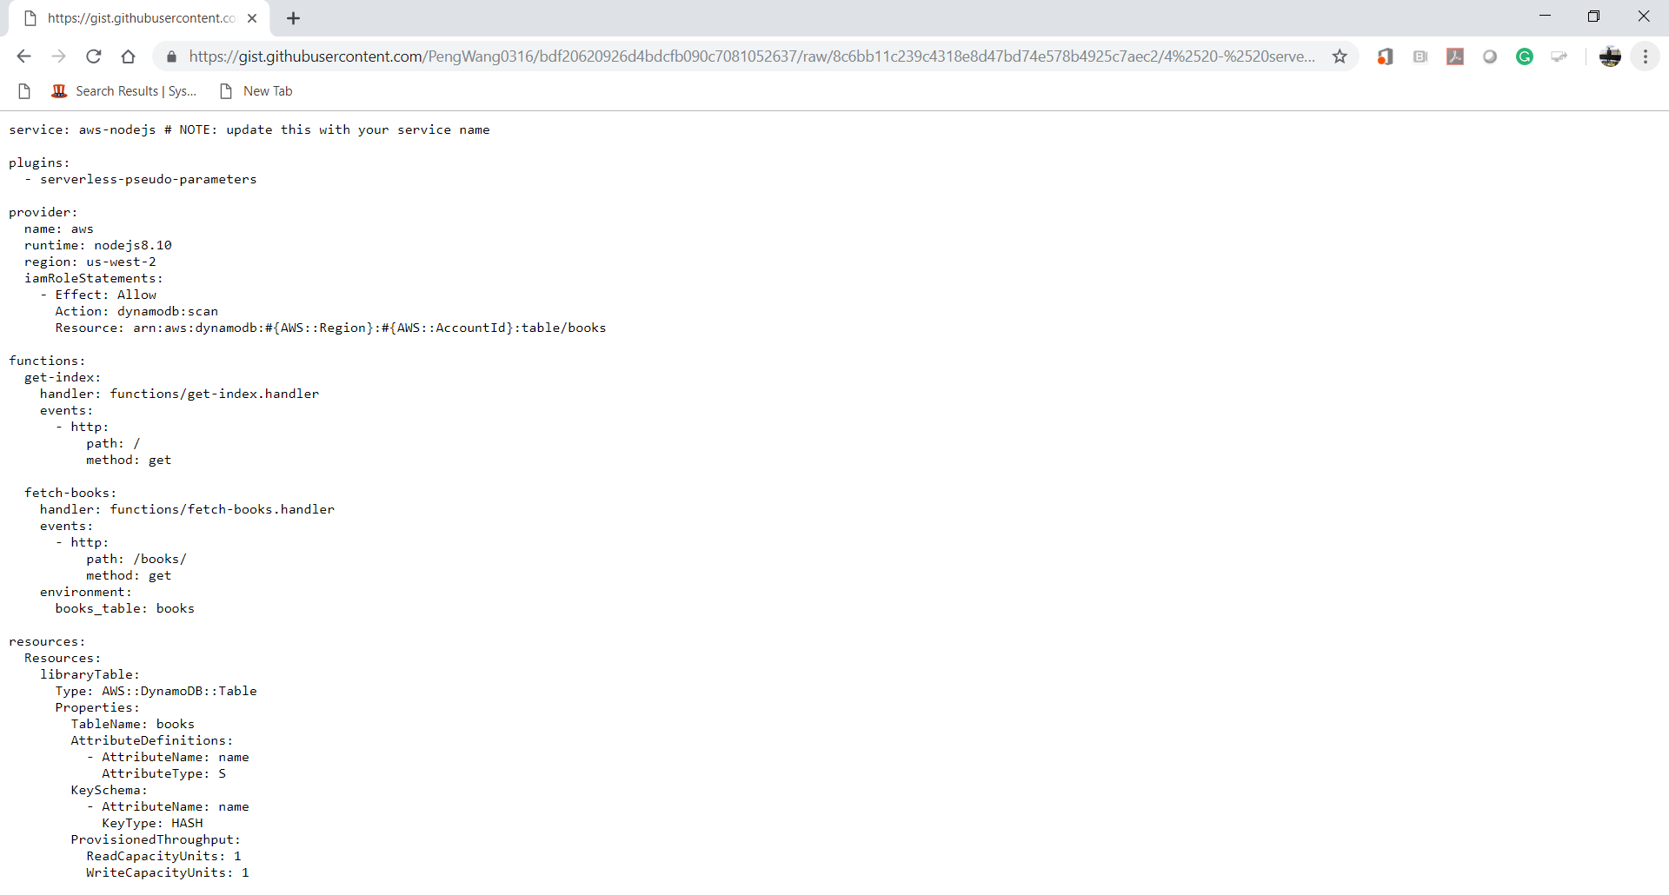

**Lambda Function**

1. Create a “**fetch-books.js**” file under the functions folder and copy the content from <https://bit.ly/2XYKSZc> Save the file.

*Common Gotcha: Internal Server Error. Check your file-name. It should be fetch-****books****.js*

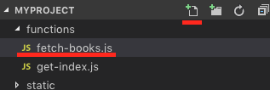   
  
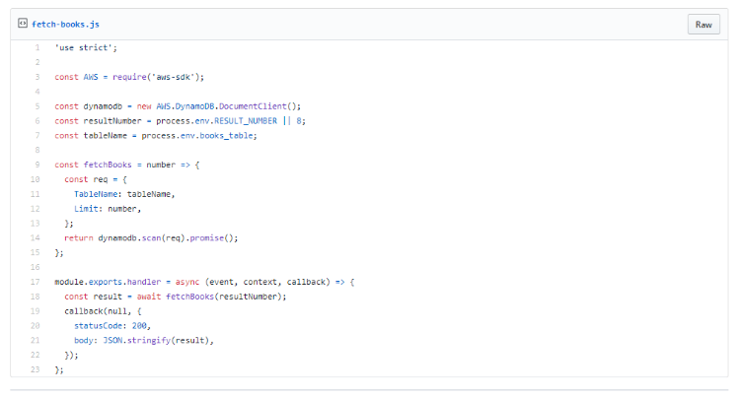

1. Open a terminal (press control and ~ keys) in VSCode and type “**sls deploy**” to deploy your new function. (**It may take a while based on your network speed**.)

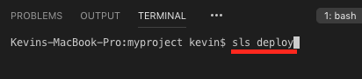

1. Access your “AWS Management Console” and visit your “Lambda” service.  
   Then, visit your Lambda function that you just created.

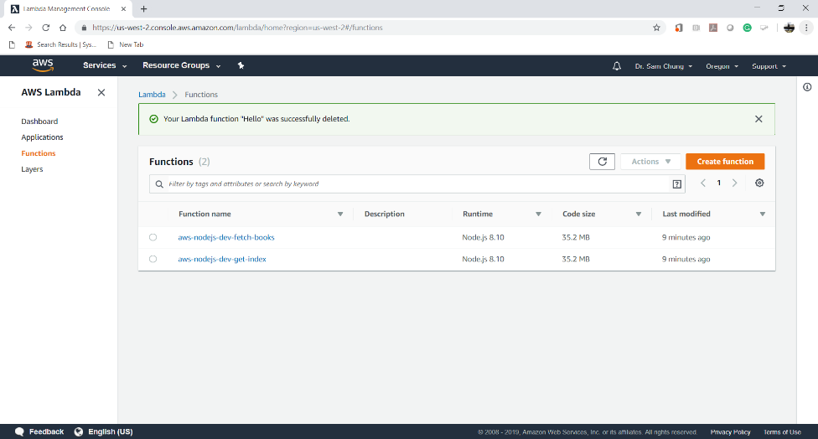

**Data Load**

1. Create a “**seed.js**” file under the **root** folder and copy content from <https://bit.ly/2VmZ9gP> to insert some fake data for testing. Save the file.  
   Eight (8) books are loaded into your “books” table.

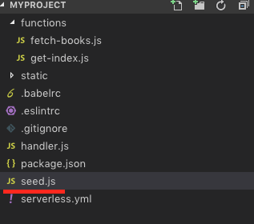

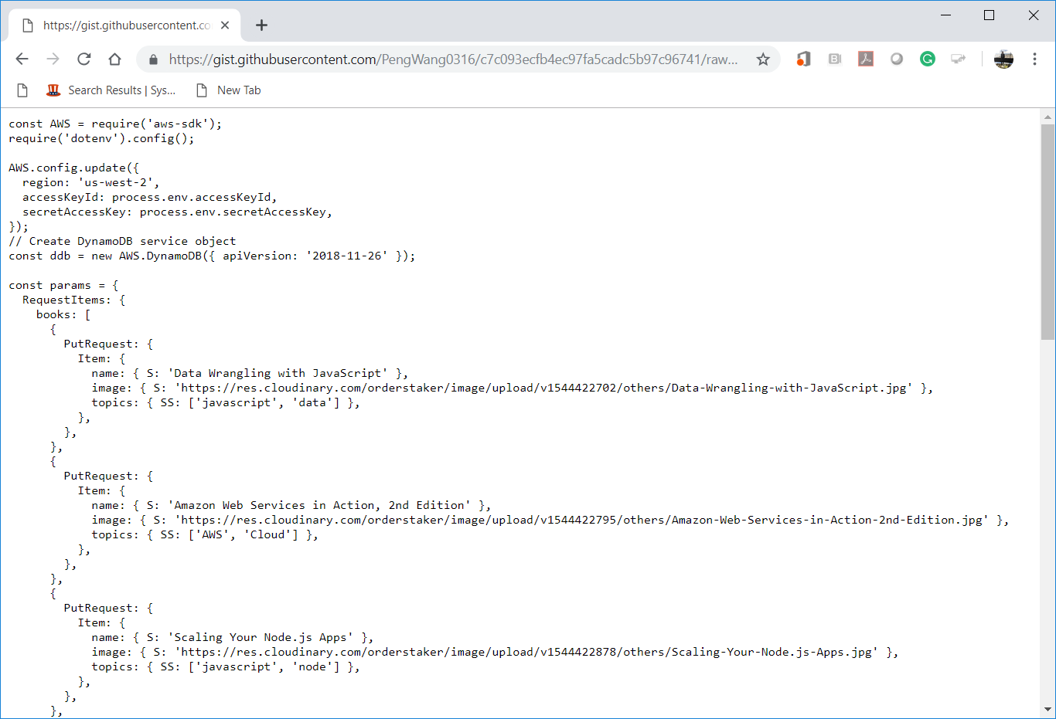

1. Open the terminal in the VSCode and type “**node seed.js**” to insert data

/var/folders/34/3jns11qs1nd6qd5csswy30mc0000gn/T/com.microsoft.Word/Content.MSO/3B36FFDA.tmp

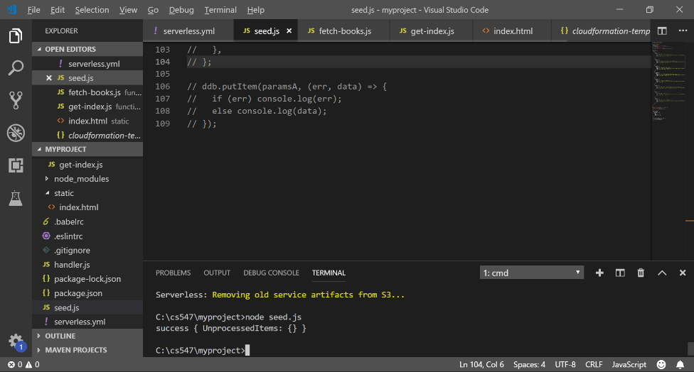

1. Type “**sls deploy**” in the terminal to deploy the change

 

1. Copy the URL from “**endpoints**” and put it in the browser to invoke it or press “ctrl+click” to follow link.

   
Note: you will have different URL endpoints.

Keep this endpoint and use it in the next step

Web Application

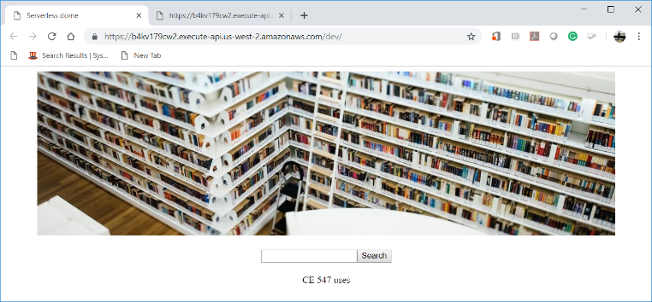

DynamoDB Data

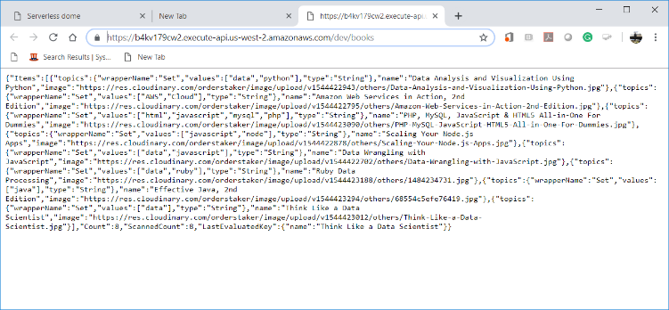

**Updating the Web Application**

1. Open “**serverless.yml**” file under the root folder and add environment statement under the get-index function (**Replace the endpoint with your own that you get from last step**)

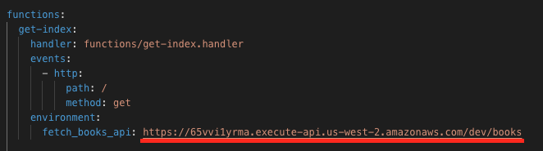 

1. Open the “**get-index.js**” function.  
   Update it with <https://bit.ly/2XW3jhh>.   
   Find which statements were added or modified.  
   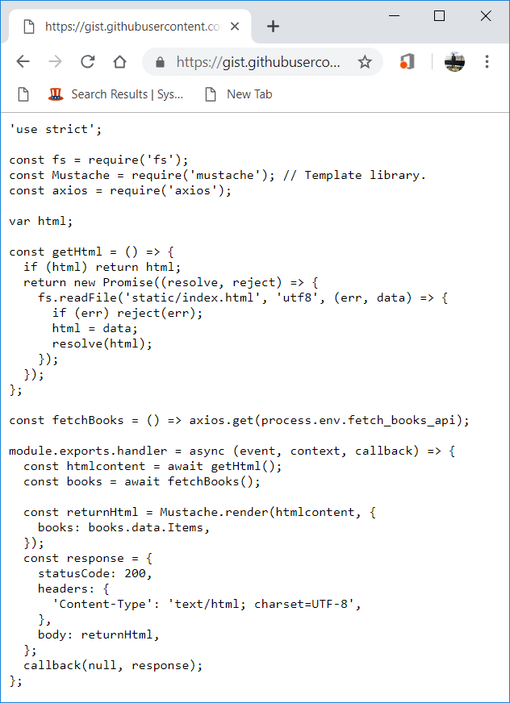
2. Open the “**index.html**” file and update the content with <https://bit.ly/3bqF7HJ>  
   Find which statements were added or modified.

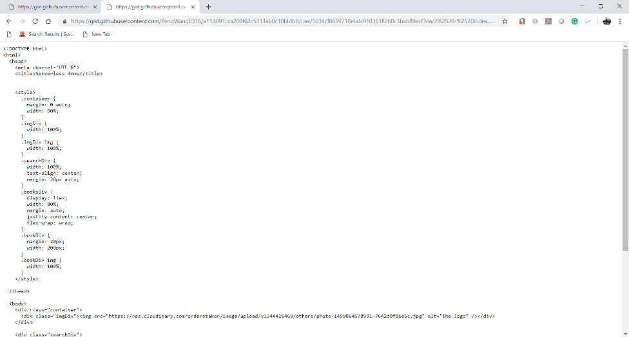

1. Open the terminal and run the “**sls deploy**” command.

 

1. Open the “get-index” endpoint in your browser to see the new changes we made

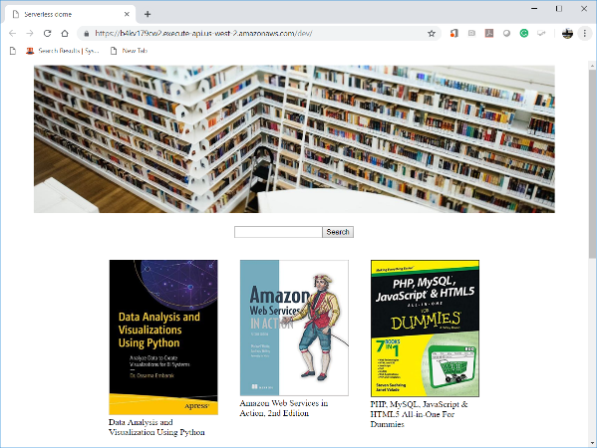

**Push your work to GitHub**

Open the terminal from the VSCode by hit the control + ~ key and type the following command:

Run the following commands to push your work to the GitHub repository:

>>> git add .

>>> git commit -m “Submission for Module 5A”

>>> git push origin YOUR_BRANCH_NAME

**Note**: you should change the YOUR_BRANCH_NAME to your own branch name. It should be firstname-lastname (e.g. maria-gracia).

If you cannot remember, run the command “git status” to check